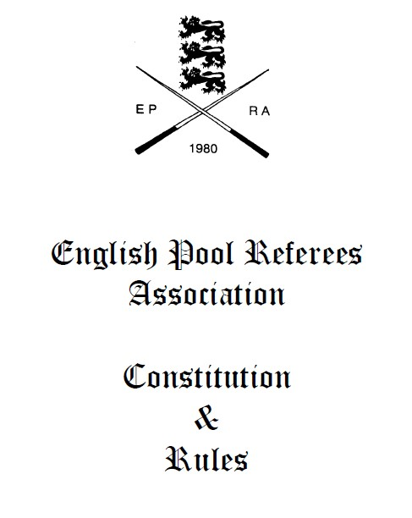

CONSTITUTION AND RULES

The name of the organisation is the English Pool Referees Association (EPRA) (Hereafter called The Association).

The Association recognises the English Pool Association (EPA) as the governing body for pool in England.

The Association is formed for the purpose of administering and upholding the Rule Sets of pool as sanctioned by the English Pool Association, without exception, and to afford to any interested person the opportunity of sitting an examination compiled in liaison with the English Pool Association. Provided that the agreed fee is paid and sufficient numbers take part to cover expenses.

RULES

- The Association shall elect a committee to manage all business appertaining to the Association.

- The committee shall consist of five officers; Chairperson, Vice Chairperson,
General Secretary, Treasurer and Examination Secretary, each of whom will be eligible for re-election at the periods set out.

- The five main officials will hold office for three years with retirement starting with the Treasurer and Vice Chairman, General Secretary and Examination Secretary, and then Chairperson. All other committee members will hold office for two years. The Retiring officer’s positions will be open for election at the Annual General Meeting Providing nominations have been received by the General Secretary no later than 28 Days prior to that Annual General Meeting.
The committee is to appoint any other member of the committee to stand for any post that may become vacant.

- The committee shall have the authority to make any decision that in their opinion is deemed necessary or beneficial to its members, except issues that contravene the constitution.

- Three officers of the committee shall constitute a quorum for the purpose of carrying on the business of the Association.

MEMBERSHIP:

6a. Membership to the Association will be open to any person obtaining the required examination pass mark as set by the Association, and upon payment of the membership fee as set by the Association.
6b. Successful candidates passing either the D Grade or the E Grade examinations should complete a Membership Form and may join the Association straight away; however they will not be required to pay their Membership Fee until the next renewal date following the exam, i.e. 30th November.
6c. Candidates who pass the E Grade examination will automatically become members of the association as shown in section (b) however, they will not be issued with a membership card or registration number until they have paid their first membership fee upon renewal.
6d. Candidates who take the D Grade exam, but do not come up to the required standard for the D Grade, but reach the standard for the E Grade, may be credited with an E Grade pass following the Examination Secretary’s assessment. They then will become members of the association as set out in section (c) above.
6c. The Membership period shall be from 1st January to 31st December of the same year.

- Anyone who has passed the World Rules examination, or the E grade examination, and has allowed their membership to lapse for over 12 months, may at any time reapply for membership. Such application would be considered by the Executive Committee and the referee would normally be readmitted at the lowest grade applicable to their examination success.

- Only fully paid up members will be eligible to officiate on behalf of the Association at any tournaments, competitions or any other events.

- Where a referee is upgraded, or downgraded for any reason, during the course of the year, the membership fee for the new grade will become payable on the following 30th November. In either case there will be no financial adjustment made to the membership fees paid for the current year.

10a. Any member who resigns from the Association, at anytime during the year, will not be allowed to automatically renew their membership when due. Such application would be considered by the Executive Committee so that the circumstances of the referee’s resignation may be taken into consideration.
10b. Any member deemed to have resigned from the Association, for any reason, will not be eligible for any refund of that current years membership fee.
10c. Any member who wishes to renew their Membership, when they have deemed to have resigned (see Discipline: Rule 16:), can only do so with the joint agreement of both the EPRA and the EPA Committees’.

REGIONAL DELEGATES:

11a. Each EPRA Region, as defined by the English Pool Association, shall elect a referee (Delegate) to represent that Region at Delegates Meetings of the EPRA. The Delegate will supply a written report to the Delegates Meeting detailing all activity; examinations etc. within their Region, and subsequently report back to the EPA Regional Meetings all relevant information.
11b. It will be the responsibility of the incumbent Delegate to notify all EPRA members within their region the date and venue of Annual General Meetings; and to give notice of any candidates for election to the position of Delegate. Membership of the Regional Referees Association will not affect the voting rights of individual EPRA members.

12. (a) Regional delegates once appointed will remain in office for two years.
(b) The elections for Regional Delegates in odd numbered Regions, e.g. 1, 3, 5 & 7 shall take place in odd numbered years, and even numbered Regions (2, 4, 6 & 8) will take place in even numbered years. The relevant year will be the effective working year, regardless of when the Regional AGM is held

- The Executive Committee shall consist of the elected officers, with Regional delegates making up the full committee. Each officer and delegate shall be entitled to have a vote at committee meetings.
EPRA Rules & Constitution: Issue number 11 4

DISCIPLINE:

- Committee members may only be removed from office by a majority vote at an Extra-ordinary meeting or Annual General Meeting.

15a. The committee shall reserve the right to suspend, fine, expel or take any other action deemed necessary against any member for breach of these rules, or any rules made by the committee in the future, or for any act deemed by the committee to have brought the Association into disrepute.
15b. Upon receipt of any complaint against a member under rule 15, the facts and all relevant information shall be passed to a disciplinary subcommittee for consideration. The sub-committee will consist of the Vice Chairman, plus the Delegates of two regions nearest to that of the accused person (but not their own Delegate). Any appeal to the decision made by the sub-committee will be heard by the full committee, and must be lodged within 28 days.

16a. Any member who officiates at any event using any Rule Set not sanctioned by the
English Pool Association shall be deemed to have resigned their membership of the
Association, with immediate effect. (see Rule 10(b):)
16b. Any member disciplined under Rule 16a who wishes to renew their membership, after any required period stipulated, can only do so with the full agreement of both the EPRA and the EPA.
16c. Social Media: Members will refrain from posting, on any Social Media site, MATERIAL that can be regarded as defamatory of, prejudicial to or detrimental to the Association. Doing so may be regarded as Bringing the Association into disrepute.

MEETINGS:

17a. Annual General Meetings will be held on the last Sunday in January each year.
Each member of the Association who has paid the required membership fee by the
30th November preceding the Annual General Meeting, and is in attendance at any General Meeting, is entitled to one vote at that General Meeting. Motions for debate and election of officers can only be proposed or seconded by members who have paid their membership fee by the 30th November preceding the Annual General Meeting. The Chairman of the Association shall not vote at a General Meeting unless a casting vote is required.
17b. Regional Annual General Meetings must take place between the end of November and the third week of January so that, where necessary, the new Delegate is elected before the EPRA Annual General Meeting proceeding the effective year of office.
17c. Any member wishing to speak at a meeting must do so through the chair. Any member who disregards the orders of the Chairman will be asked to leave the meeting and disciplinary action may be taken.

- Committee meetings will take place biannually each year in January and June. The January meeting will be held on the same day as the AGM and the date of the June meeting will be decided by the committee.

- Any Extra-ordinary General Meeting may be called by any three officers or any four Regional delegates, giving in writing to the General Secretary the reasons for such a meeting; twenty eight days clear notice must be given. The General Secretary will inform the members and the reason for the meeting will form the Agenda. No other items will be included.

ACCOUNTS:

- The Association shall be responsible for its own affairs and will compile examination papers in liaison with the English Pool Association. Fees for the examinations and membership shall be agreed at the Annual General Meeting.
- The funds of the Association shall be deposited with a bank as agreed by the committee. Monies may only be withdrawn from the bank by two signatories from three, being the Treasurer, Chairperson or General Secretary.
EPRA Rules & Constitution: Issue number 11 5

- The Treasurer will check all income and expenditure accounts for payment and at all times observe correct banking procedures. All expenses must be vetted by the committee.

- The Treasurer will provide a correct balance sheet at the Annual General Meeting, plus an updated bank statement at every meeting. The accounts must be audited by two volunteers from within the Association annually, in time for the Annual General Meeting.

This Constitution shall remain unchanged unless notice is received for changes twenty eight days before the Annual General Meeting, in order for proposed changes to be included in the Agenda.

The Association, at their own discretion, reserve the right to refuse membership.

Membership of the Association signifies acceptance of the Associations ‘Constitution and Rules’ in their entirety.

Originated 1980

Amended 1985 / Amended 1988 / Amended 1996 / Amended 1998 / Amended 1999 /
Amended 2003 / Amended 2004 / Amended 2005 / Amended 2006 / Amended 2007 / Amended 2008 / Amended 2010 / Amended 2011 / Amended 2013 / Amended 2017 /

